Tutorial 14

Exercise I - Requirements
Think of possible entities (things) that should be recorded for applicants’ admission in WIUT. Draw a simple ER diagram of the entities.

Programming Exercise II – New project
You will have to resemble the structure created in Exercise I in a .Net project.
- If you haven’t done so before, install SQLite tools by running “SQLite_and_SQL_Server_Compact_Toolbox_v4.8.761.vsix” file available on intranet.
- Create new project in Visual Studio. Call it WIUT.
- Go to Tools -> SQLite/Sql Server Compact Toolbox
- Right-click the Data Connections, select “Add SQLite Connection” option.
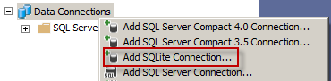
- Click on Create button and navigate to the project folder (go inside WIUT folder from the default location you will be shown). Call it WIUT.db, test connection and click on Close button. If you created the file in the proper location, you should see it under the project structure:
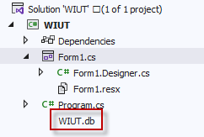
- Right-click WIUT.db and click on “Build Table” option
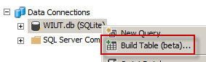
- Create Applicant table as follows:
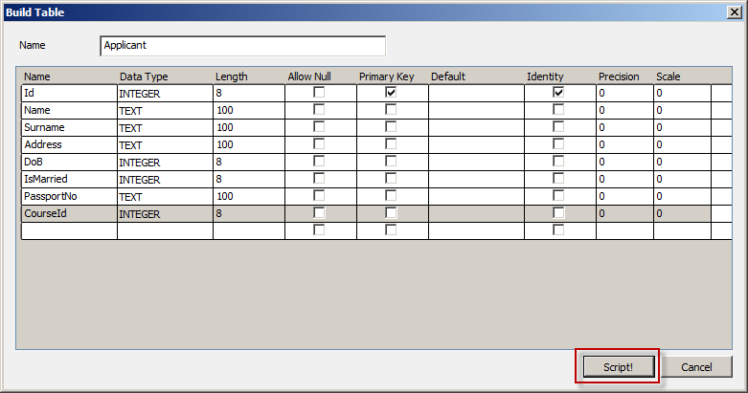

Once you’re done with the structure, click Script button and execute the script with “play” button from the toolbar:
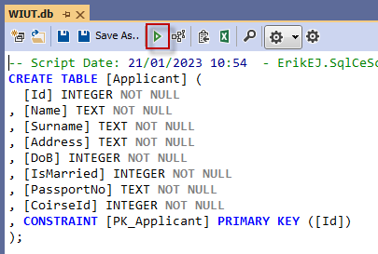

If everything went OK you should see the following in the bottom part of the window:
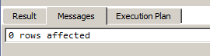

and new table should be shown in the database tree:
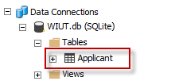

- Similarly, create Course table in the database (don’t forget to generate and execute the script for creating the table):
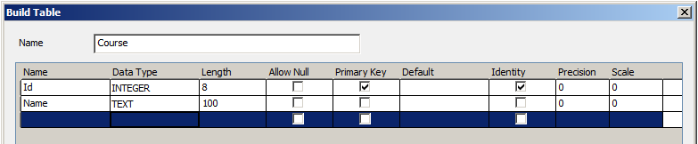

- Right-click each of the tables and use “Edit top 200 Rows” option to populate the database with sample input
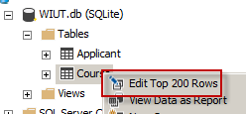

- Resemble corresponding classes in your C# project. Set up member variables, properties and constructors.
  - Right click the project and select Add -> New class
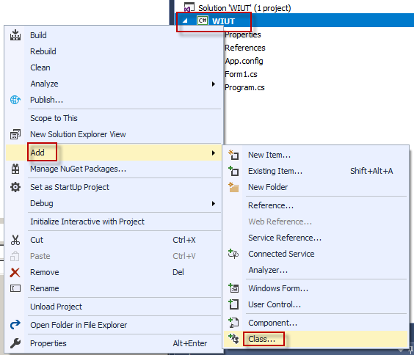

  - Name the class as the database table
  - Add properties for each of the database fields
  - Add parameterless constructor
  - Add constructor with all the fields
- Create FormLoad event in the Form1 and create an applicant and a course. Show some properties of the applicant in messagebox:

private void Form1_Load(object sender, EventArgs e)
{
var bis = new Course("BIS");
var applicant = new Applicant("Anna",
"Kozlova",
"T. Malik 100/15",
new DateTime(1995, 4, 10),
true,
"AA 123456",
bis);
MessageBox.Show($"{applicant.Name} is on {applicant.Course.Name}");
}

Home work
Recap SQL statements used to retrieve, create, update and delete data from a database.

